Behavioral Results

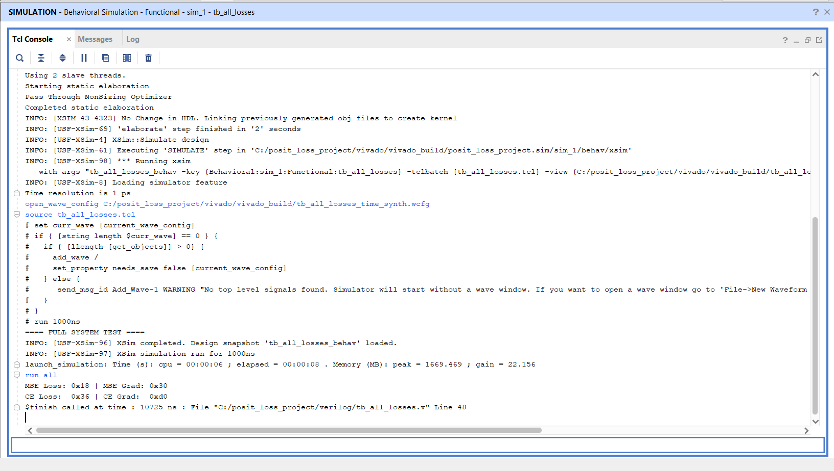
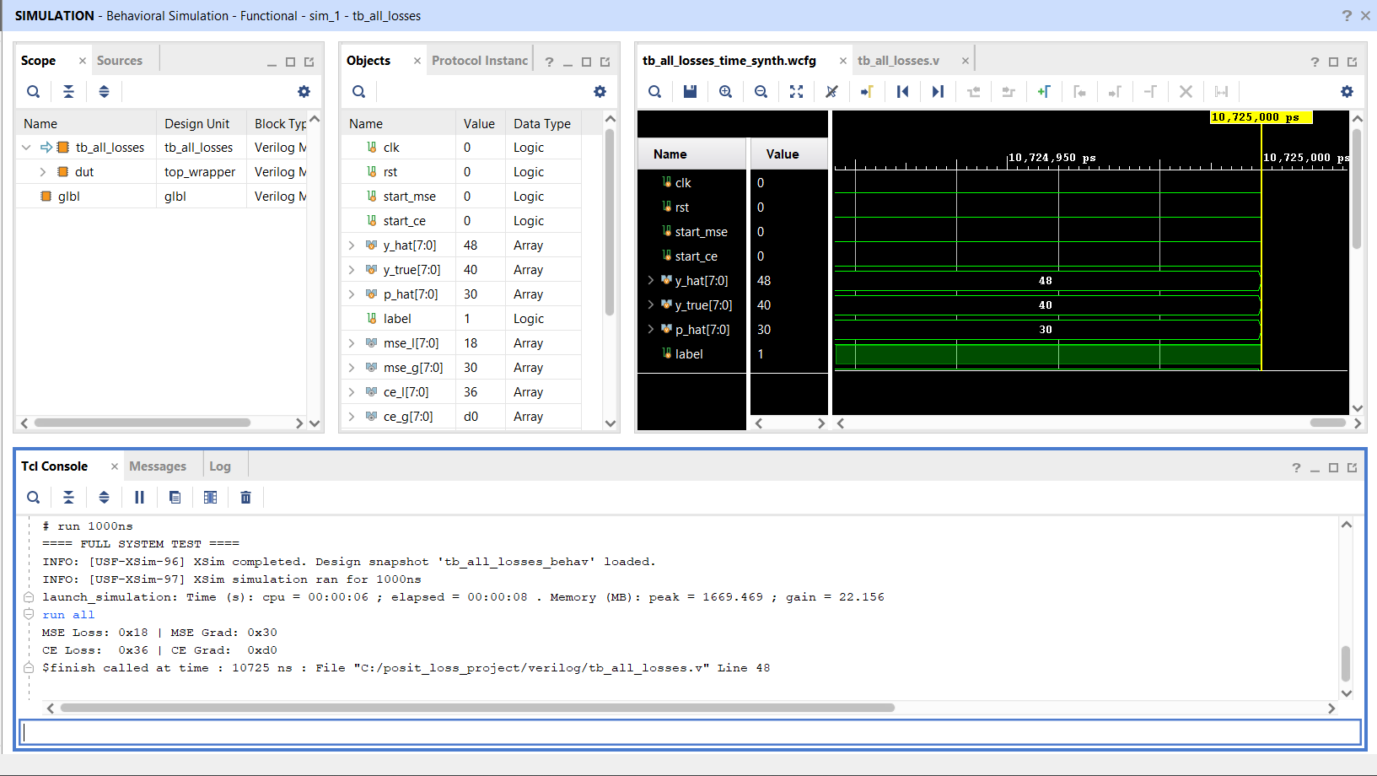

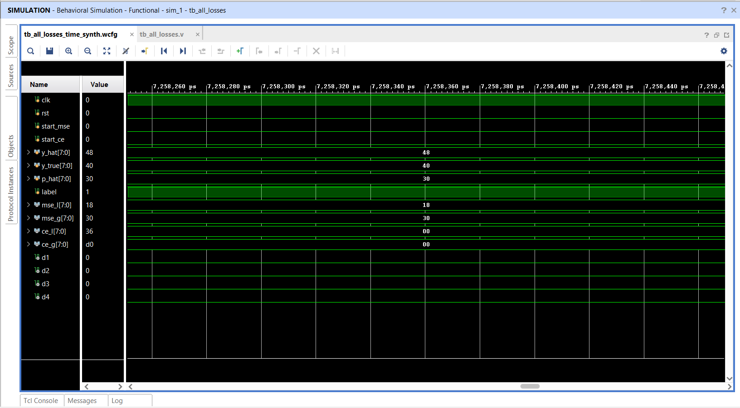
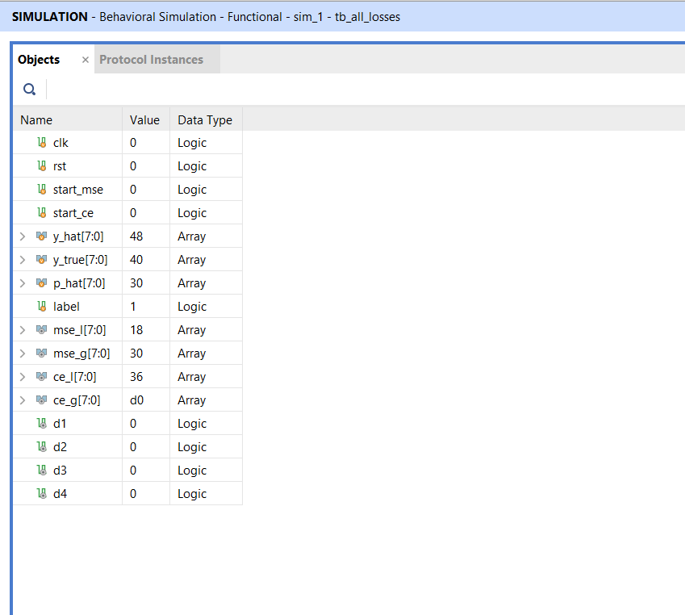

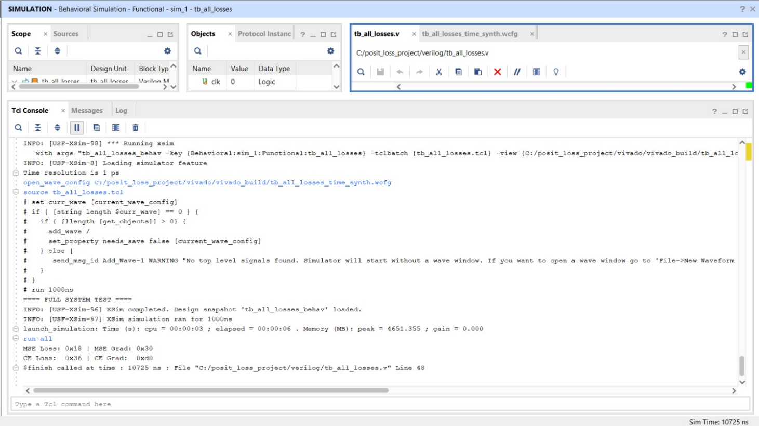

---------------------------------------------------------------------------------
Finished Writing Synthesis Report : Time (s): cpu = 00:00:40 ; elapsed = 00:00:43 . Memory (MB): peak = 1962.871 ; gain = 1183.070
---------------------------------------------------------------------------------
Synthesis finished with 0 errors, 0 critical warnings and 0 warnings.
Synthesis Optimization Runtime: Time (s): cpu = 00:00:30 ; elapsed = 00:00:41 . Memory (MB): peak = 1962.871 ; gain = 1115.715
Synthesis Optimization Complete : Time (s): cpu = 00:00:40 ; elapsed = 00:00:43 . Memory (MB): peak = 1962.871 ; gain = 1183.070
INFO: [Project 1-571] Translating synthesized netlist
Netlist sorting complete. Time (s): cpu = 00:00:00 ; elapsed = 00:00:00.018 . Memory (MB): peak = 1972.023 ; gain = 0.000
INFO: [Netlist 29-17] Analyzing 98 Unisim elements for replacement
INFO: [Netlist 29-28] Unisim Transformation completed in 0 CPU seconds
INFO: [Project 1-570] Preparing netlist for logic optimization
INFO: [Opt 31-138] Pushed 0 inverter(s) to 0 load pin(s).
Netlist sorting complete. Time (s): cpu = 00:00:00 ; elapsed = 00:00:00.001 . Memory (MB): peak = 1976.676 ; gain = 0.000
INFO: [Project 1-111] Unisim Transformation Summary:
No Unisim elements were transformed.

Synth Design complete | Checksum: f0ca5c31
INFO: [Common 17-83] Releasing license: Synthesis
48 Infos, 2 Warnings, 0 Critical Warnings and 0 Errors encountered.
synth_design completed successfully
synth_design: Time (s): cpu = 00:00:45 ; elapsed = 00:00:50 . Memory (MB): peak = 1976.676 ; gain = 1440.512
Write ShapeDB Complete: Time (s): cpu = 00:00:00 ; elapsed = 00:00:00.006 . Memory (MB): peak = 1976.676 ; gain = 0.000
INFO: [Common 17-1381] The checkpoint 'C:/posit_loss_project/vivado/vivado_build/posit_loss_project.runs/synth_1/top_wrapper.dcp' has been generated.
INFO: [Vivado 12-24828] Executing command : report_utilization -file top_wrapper_utilization_synth.rpt -pb top_wrapper_utilization_synth.pb
INFO: [Common 17-206] Exiting Vivado at Mon Apr 20 19:34:18 2026...

